# CS 255 System Design Document

## UML Diagrams

### UML Use Case Diagram

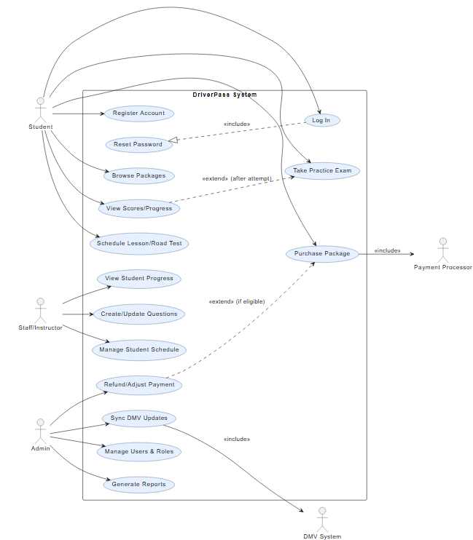

### UML Activity Diagrams

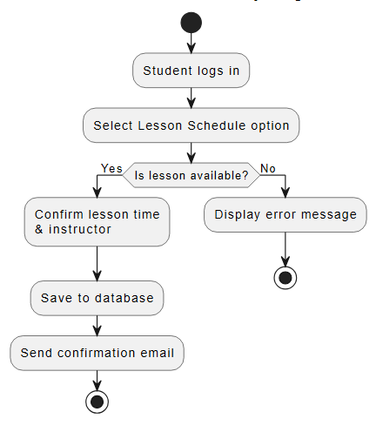

### UML Sequence Diagram

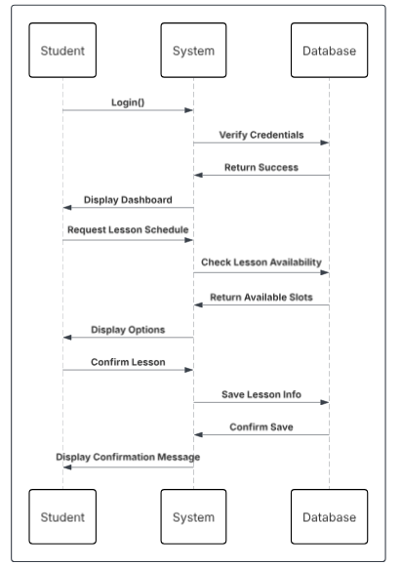

### UML Class Diagram

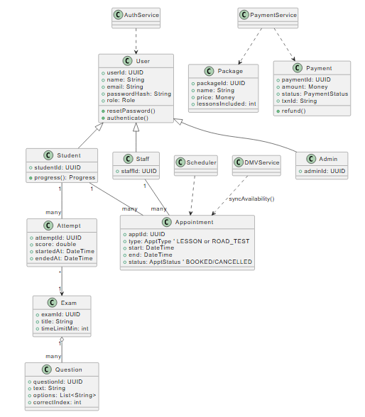

## Technical Requirements

Hardware Requirements:  
- Cloud-hosted server with sufficient storage for lesson data and test results.  
- Reliable internet connection for all users.  
- Devices: Desktop computers, tablets, and mobile phones.  
  
Software Requirements:  
- Web-based application (HTML5, CSS3, JavaScript, SQL database).  
- Secure API integration for payments and DMV data updates.  
- Browser compatibility across Chrome, Edge, Safari, and Firefox.  
  
Infrastructure:  
- Cloud hosting provider with automatic backups.  
- Scalable database for concurrent student access.  
  
Security Requirements:  
- Role-based access control (student, secretary, admin, IT officer).  
- Encrypted passwords and secure login with recovery options.  
- PCI-compliant credit card processing.  
- Audit trail for activity tracking and system changes.  
  
Performance and Usability:  
- Load time under 3 seconds for tests and reports.  
- Mobile-friendly interface with simplified navigation.  
- Supports concurrent users without performance degradation.  
  
Limitations:  
- Offline access limited to downloadable reports.  
- DMV updates dependent on third-party API reliability.  
- Module modifications require developer access.